Azure Database Access for your Tutor
Now that we are marking your work remotely, when we try to access your database on Azure, we will get the following error…
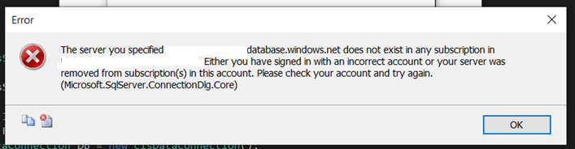
The problem is that your Azure firewall needs the rules updating to allow access by your tutor.
We will need access to your database to mark the work properly!

Instructions for database owners
You need to be the owner of the Azure database to do this. Login to the Azure portal with your Uni login you should see a screen like this…
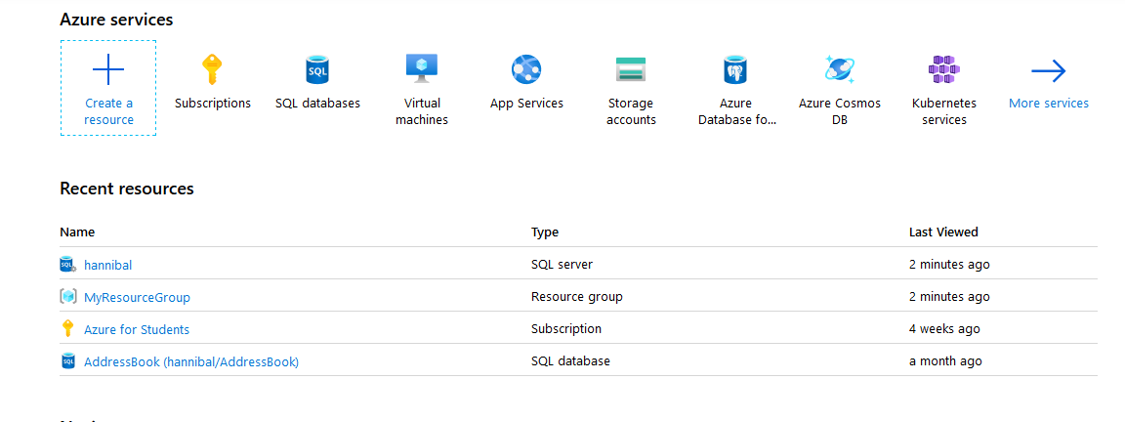
You need to click on the name of your server (in this example hannibal) this will take you to the next screen…
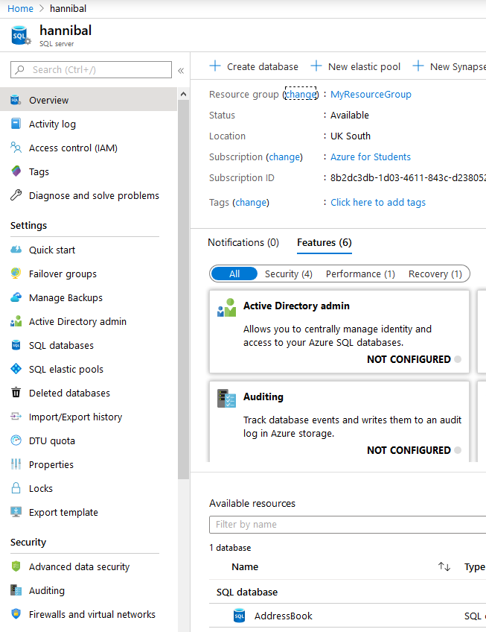

Click on Firewalls and virtual networks in the bottom left
This will take you here…
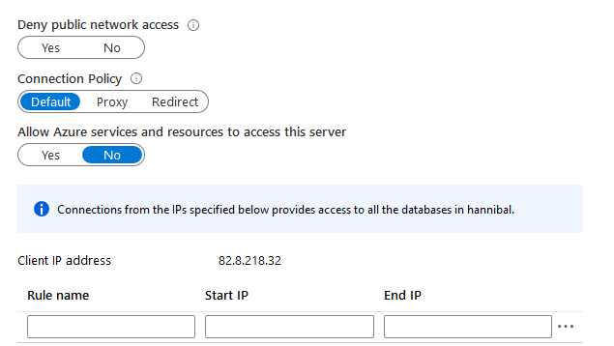
You need to enter here the IP address range of your tutor(s).
Matthew (IMAT2204 & IMAT3903)
82.8.218.0 to 82.8.218.255
Hakeem (IMAT2204)
80.209.178.0 to 80.209.178.255
You may add a new rule in the empty boxes...
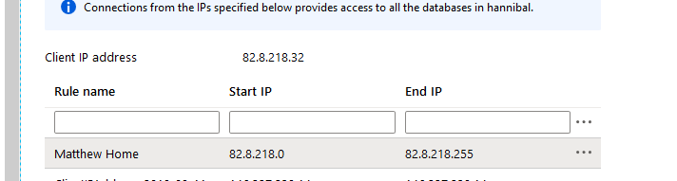
Press return and it will add the new firewall rule below.
Once this is done your tutor should have access to your server.

